EE564 PROJECT #3

TRACTION MOTOR DESIGN

CİHAN AYDAR

2043677

TABLE OF CONTENTS

1. INTRODUCTION 3

2. MOTOR PARAMETER ESTIMATION 3

4. DETAILED ANALYSIS AND VERIFICATION 4

4.1 INPUTS 5

4.2 OUTPUTS 7

5. CONCLUSION 19

6. REFERENCES 20

7. APPENDIX 20

LIST OF TABLES

Table 1 Winding Design Parameters 3

Table 2 Motor Dimension Calculations 4

LIST OF FIGURES

Figure 1 Stator Inputs 5

Figure 2 Stator Geometry 5

Figure 3 Stator Winding 5

Figure 4 Stator Insulation 6

Figure 5 B-H Characteristics 6

Figure 6 Rotor Structure 6

Figure 7 Rotor Geometry 6

Figure 8 Output Data 7

Figure 9 Locked Rotor Operation 8

Figure 10 Material Consumption 9

Figure 11 No Load Operation 9

Figure 12 Rated Electric Data 10

Figure 13 Rated Parameters 11

Figure 14 Rated Performance 12

Figure 15 Stator Slot Geometry 13

Figure 16 Stator Winding 13

Figure 17 Phase Current vs Output Power 14

Figure 18 Phase Current vs Speed 15

Figure 19 Power Factor vs Output Power 16

Figure 20 Power Factor vs Speed 16

Figure 21 Efficiency vs Output Power 17

Figure 22 Efficiency vs Speed 18

Figure 23 Torque vs Speed 18

Figure 24 Induced Voltages vs Time 18

Figure 25 Input Phase Currents 19

# 1. INTRODUCTION

The main purposes of project are to design a traction squirrel cage induction motor (with copper rotor-bars) and then verify it in a FEA program. Specifications of the motor can be seen as follows.

* Rated Power Output: 1280 kW
* Line-to-line voltage: 1350 V
* Number of poles: 6
* Rated Speed: 1520 rpm (72 km/h) (driven with 78 Hz inverter)
* Rated Motor Torque: 7843 Nm
* Cooling: Forced Air Cooling
* Insulating Class: 200C
* Train Wheel Diameter: 1210 mm
* Maximum Speed: 140 km/h
* Gear Ratio: 4.82

# 2. MOTOR PARAMETER ESTIMATION

Here motor geometry is determined. All calculation methodology can be seen in Excel file. [1]

|  |  |  |  |  |  |
| --- | --- | --- | --- | --- | --- |
| **Number of Poles** | 6 |  |  |  |  |
| **Type of Winding** | Integral, Single Layer, Distributed Winding |  |  |  |  |
| **Winding Factors** | 0,9598 | 0,66667 | 0,21757 | -0,1774 | -0,3333 |
| **Number of Turns** | 36 |  |  |  |  |
| **Fill Factor** | 0,7 |  |  |  |  |
| **Winding Connection** | wye |  |  |  |  |
| **Voltage Rating (V)** | 1350 |  |  |  |  |
| **Current Rating (A)** | 547,43 |  |  |  |  |
| **Output Power Rating (W)** | 1280000 |  |  |  |  |
| **Frequency** | 78 |  |  |  |  |

Table 1 Winding Design Parameters

|  |  |  |  |
| --- | --- | --- | --- |
| **Number of StatorSlots** | 54 |  |  |
| **Slots per Pole** | 9 |  |  |
| **Slot per Pole per Phase** | 3 |  |  |
| **Slot Angle (degree)** | 20 | 0,34907 |  |
| **Conductors per Slot** | 4 |  |  |
| **Nphase** | 36 |  |  |
| **Flux per Pole (Wb)** | 0,05897 | 0,06514 |  |
| **Bavg (T)** | 0,7 |  |  |
| **Airgap Clearance (mm)** | 0,18093 |  |  |
| **Torque (N.m)** | 8041,51 |  |  |
| **Speed (rad/s)** | 159,174 | 1520 | rpm |
| **Maxwell Stress Tensor (N/m^2)** | 194965 |  |  |
| **Number of RotorSlots** | 62 |  |  |

|  |  |
| --- | --- |
| **Di (m)** | 0,32639 |
| **L (m)** | 0,24648 |
| **Di^2*L** | 0,02626 |
| **Aspect Ratio (L/D)** | 0,75516 |
| **Zq*Qs** | 216 |
| **Specific Electric Loading-q (A/m)** | 115316 |
| **Zq** | 4 |
| **Slot Pitch (mm)** | 0,01899 |
| **Do(m)** | 0,48959 |

Table 2 Motor Dimension Calculations

# 4. DETAILED ANALYSIS AND VERIFICATION

Final optimized values of motor geometry can be seen in following figures. In first simulation with rmxprt, efficiency, magnetic flux densities in stator and rotor cores and power factor values are not compatible with design values. Stator and rotor geometry is finalized as follows.

## 4.1 INPUTS

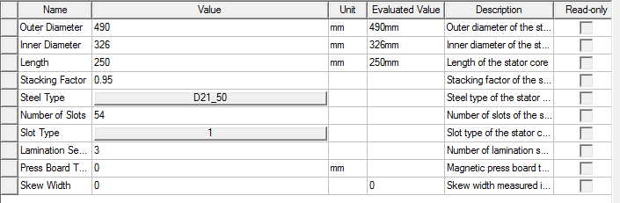

Figure 1 Stator Inputs

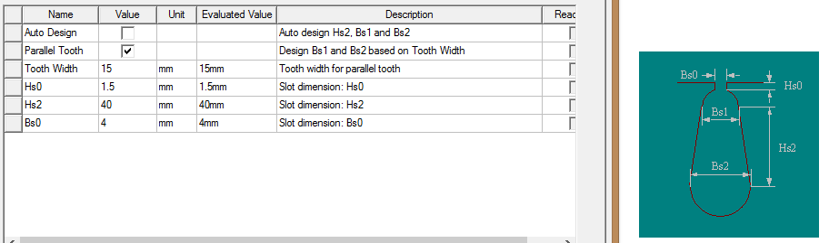

Figure 2 Stator Geometry

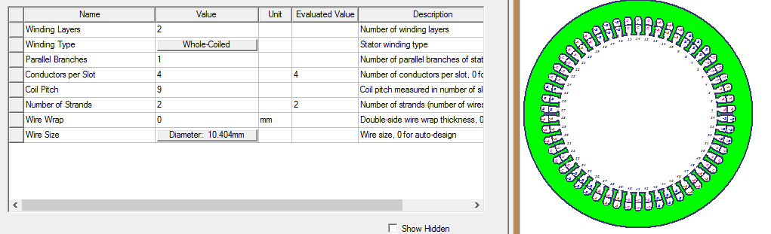

Figure 3 Stator Winding

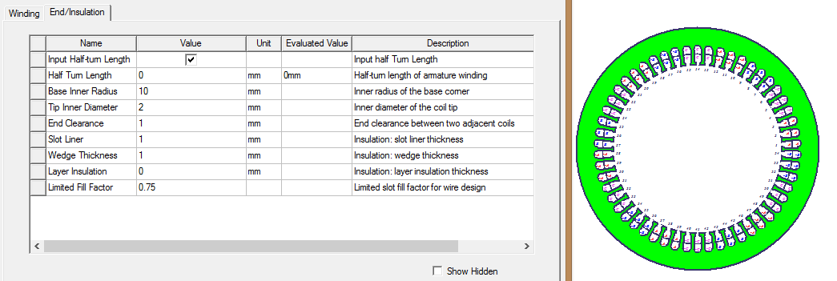

Figure 4 Stator Insulation

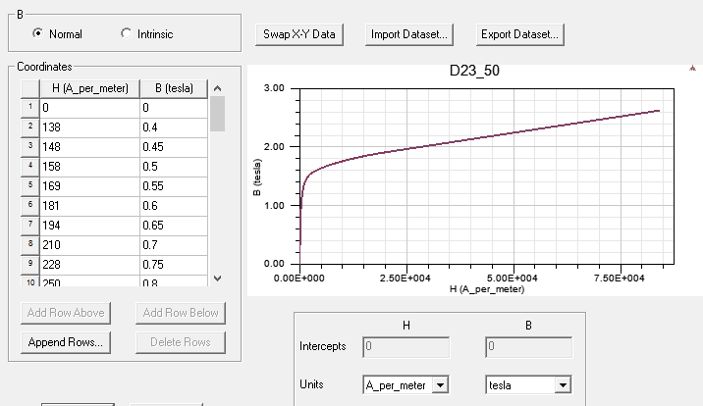

Figure 5 B-H Characteristics

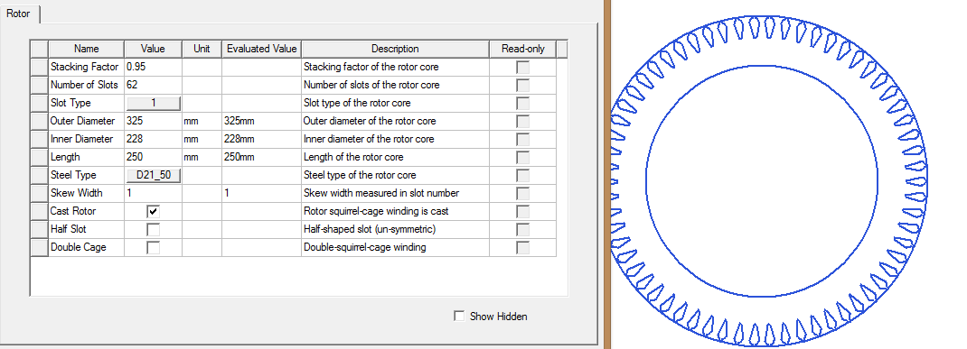

Figure 6 Rotor Structure

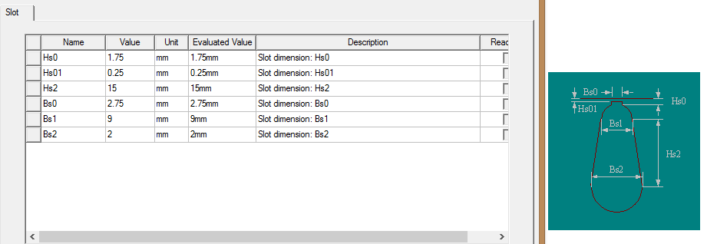

Figure 7 Rotor Geometry

## 4.2 OUTPUTS

Values in Fig. 8 are compared with the calculated values in previous parts. They are consistent with each other.

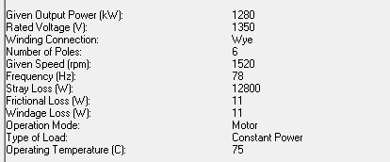

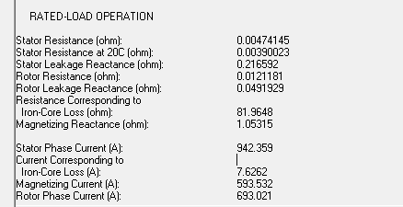

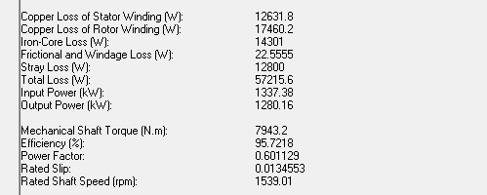

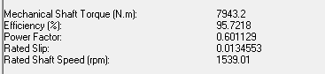

Figure 8 Output Data

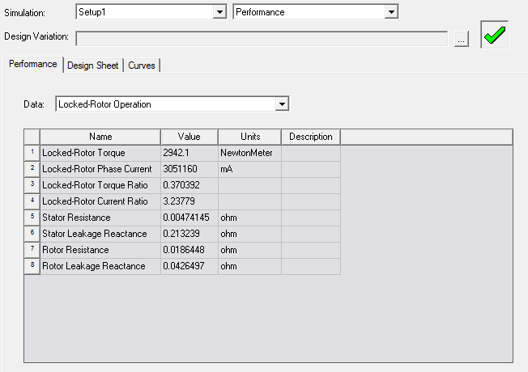

Figure 9 Locked Rotor Operation

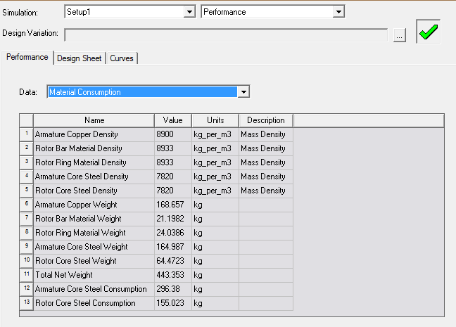

Figure 10 Material Consumption

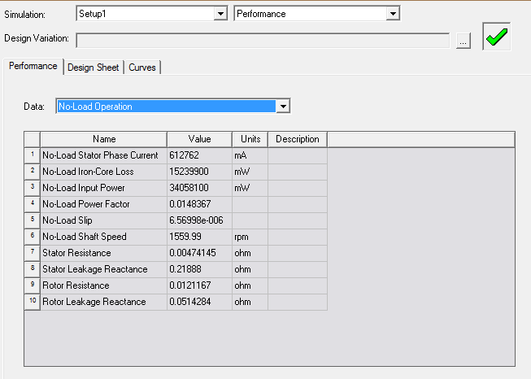

Figure 11 No Load Operation

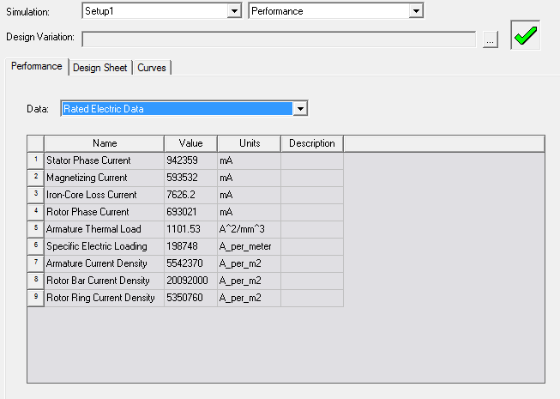

Figure 12 Rated Electric Data

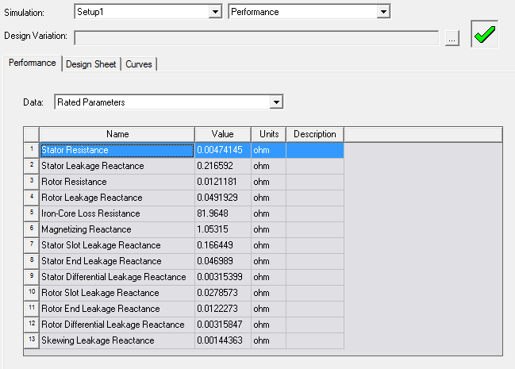

Figure 13 Rated Parameters

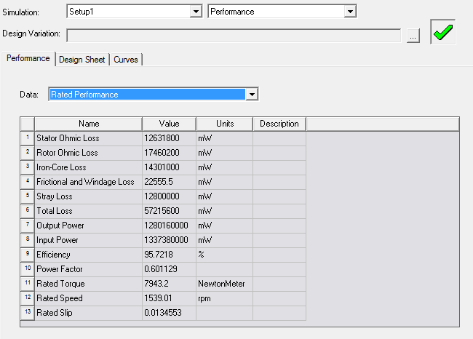

Figure 14 Rated Performance

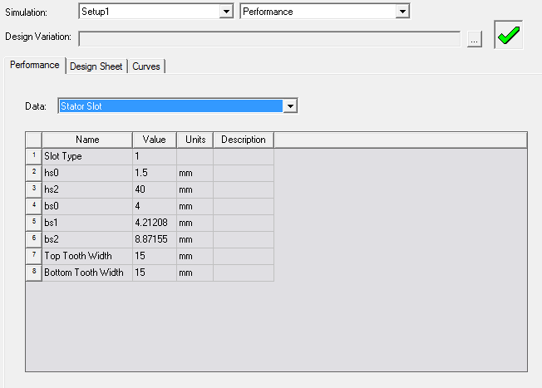

Figure 15 Stator Slot Geometry

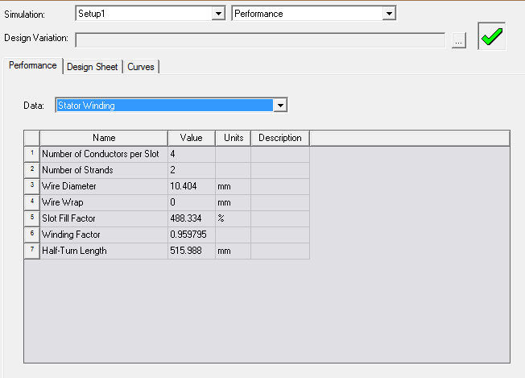

Figure 16 Stator Winding

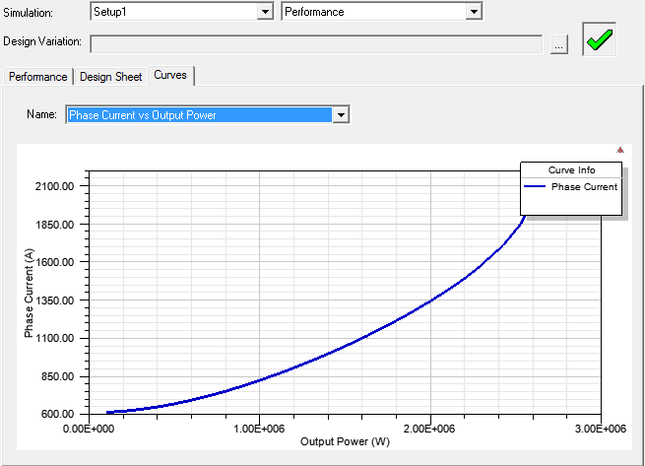

Figure 17 Phase Current vs Output Power

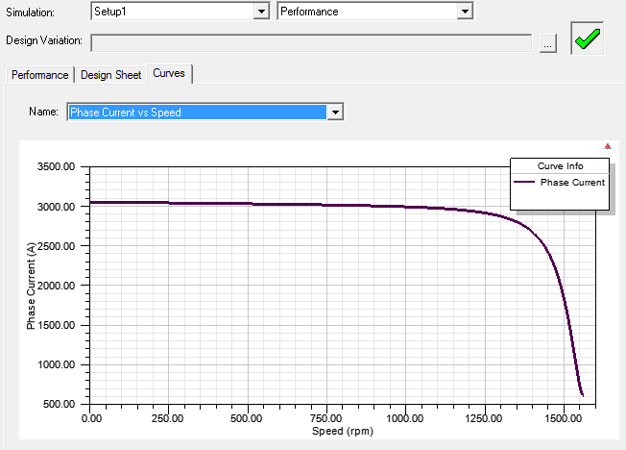

Figure 18 Phase Current vs Speed

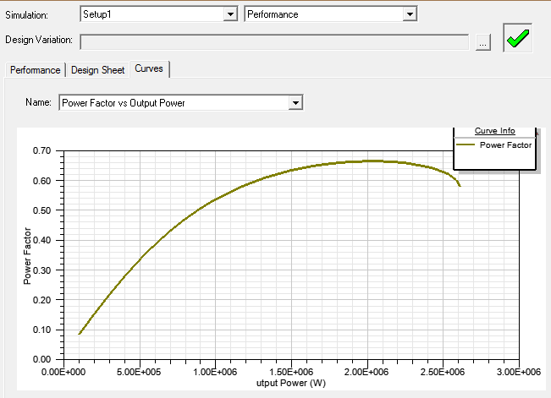

Figure 19 Power Factor vs Output Power

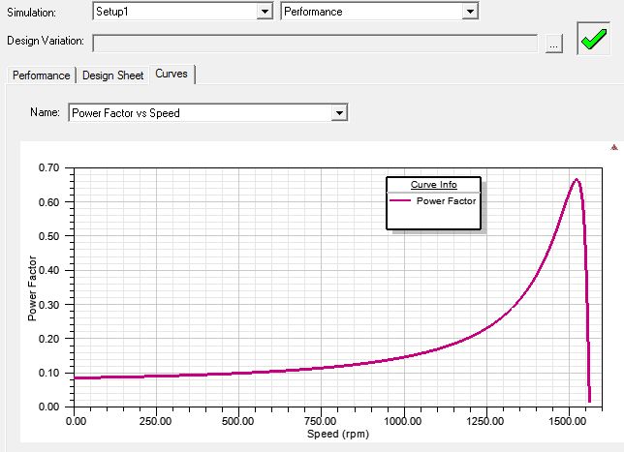

Figure 20 Power Factor vs Speed

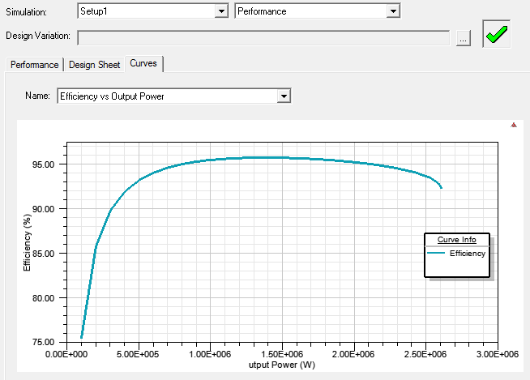

Figure 21 Efficiency vs Output Power

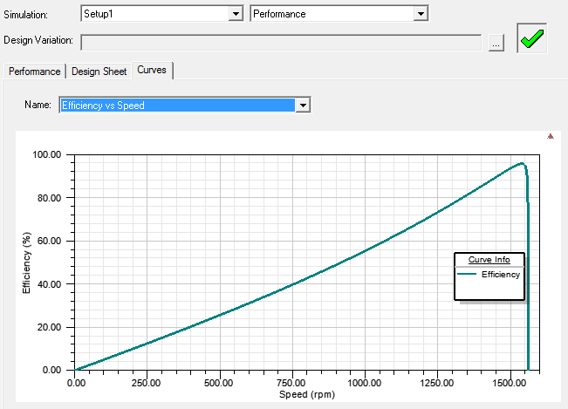

Figure 22 Efficiency vs Speed

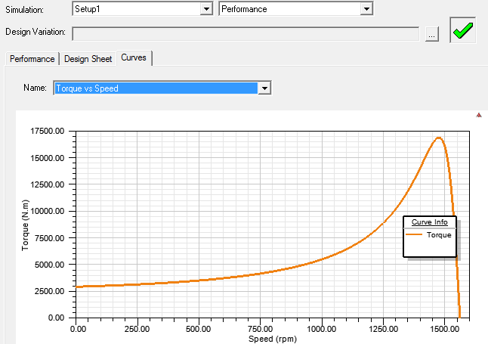

Figure 23 Torque vs Speed

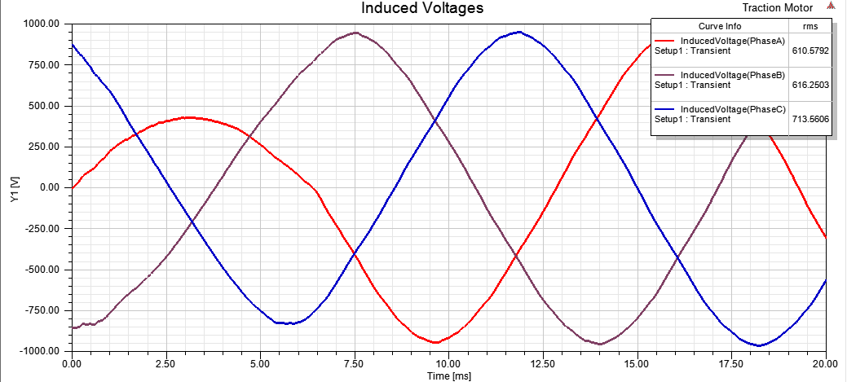

Figure 24 Induced Voltages vs Time

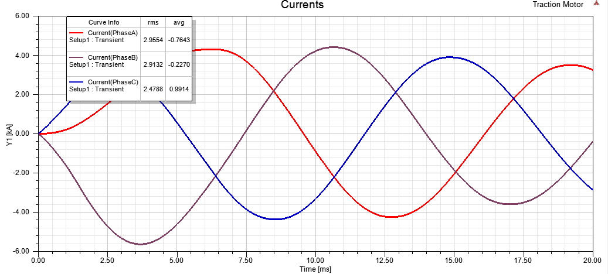

Figure 25 Input Phase Currents

# 5. CONCLUSION

Basically, algorithm in 2nd project is implemented to design a traction motor. In order to achieve design goals such as overall system efficiency, weight, cost, size, there exist lots of iteration process in Maxwell simulation tool. Firstly, according to given specifications, the relation between torque and motor geometry is found. Here, inner diameter of the core, length of the machine and magnetic flux density in the airgap are unknown. Secondly, suitable length ratio and airgap flux density is chosen. Once they are chosen, basic motor dimensions are determined. Thirdly, in order to get desired emf voltage in the airgap, number of phases and flux per pole are calculated from selection of conductors per slot and pole area considering reasonable magnetic loading value from [1]. Airgap length is calculated from rule of thumb in [1] and then optimized to have optimum magnetizing inductance value. Finally, low number of slots are chosen to have better cooling performance, reduced manufacturing cost, to use slot area more efficiently. In order not to have cogging torque, harmful vibrations and torques, the ratio between number of stator and rotor slots are considered. In addition, rotor slots may be skewed to minimize cogging effect. And then slot dimensions are determined according to back core flux density from saturation point of view of the core. Here copper rotor bars are used to have better efficiency compared to aluminium bars.

All in all, analytical approach is verified via FEA tool as seen above. All design process such as advantages and disadvantages of different stator designs, choices are referred on ‘Design of Induction Motors’ material [1].

# 6. REFERENCES

[1] Keysan, O. (2018, 03). *EE564*. Retrieved from Electrical Machine Design: http://keysan.me/ee564/

# 7. APPENDIX

Three-Phase Induction Machine Design

File: Setup1.res

GENERAL DATA

Given Output Power (kW): 1280

Rated Voltage (V): 1350

Winding Connection: Wye

Number of Poles: 6

Given Speed (rpm): 1520

Frequency (Hz): 78

Stray Loss (W): 12800

Frictional Loss (W): 11

Windage Loss (W): 11

Operation Mode: Motor

Type of Load: Constant Power

Operating Temperature (C): 75

STATOR DATA

Number of Stator Slots: 54

Outer Diameter of Stator (mm): 490

Inner Diameter of Stator (mm): 326

Type of Stator Slot: 1

Stator Slot

hs0 (mm): 1.5

hs2 (mm): 40

bs0 (mm): 4

bs1 (mm): 4.21208

bs2 (mm): 8.87155

Top Tooth Width (mm): 15

Bottom Tooth Width (mm): 15

Length of Stator Core (mm): 250

Stacking Factor of Stator Core: 0.95

Type of Steel: D21_50

Number of lamination sectors 3

Press board thickness (mm): 0

Magnetic press board No

Number of Parallel Branches: 1

Type of Coils: 21

Coil Pitch: 9

Number of Conductors per Slot: 4

Number of Wires per Conductor: 2

Wire Diameter (mm): 10.404

Wire Wrap Thickness (mm): 0

Wedge Thickness (mm): 1

Slot Liner Thickness (mm): 1

Layer Insulation (mm): 1

Slot Area (mm^2): 301.313

Net Slot Area (mm^2): 177.326

Slot Fill Factor (%): 488.334

Limited Slot Fill Factor (%): 75

**** Warning - Result is Unfeasable ****

Slot Fill Factor is beyond its limited value.

Wire Resistivity (ohm.mm^2/m): 0.0217

Conductor Length Adjustment (mm): 0

End Length Correction Factor 1

End Leakage Reactance Correction Factor 1

ROTOR DATA

Number of Rotor Slots: 62

Air Gap (mm): 0.5

Inner Diameter of Rotor (mm): 228

Type of Rotor Slot: 1

Rotor Slot

hs0 (mm): 1.75

hs01 (mm): 0.25

hs2 (mm): 15

bs0 (mm): 2.75

bs1 (mm): 9

bs2 (mm): 2

Cast Rotor: Yes

Half Slot: No

Length of Rotor (mm): 250

Stacking Factor of Rotor Core: 0.95

Type of Steel: D21_50

Skew Width: 1

End Length of Bar (mm): 35

Height of End Ring (mm): 22

Width of End Ring (mm): 65

Resistivity of Rotor Bar

at 75 Centigrade (ohm.mm^2/m): 0.0172414

Resistivity of Rotor Ring

at 75 Centigrade (ohm.mm^2/m): 0.0172414

Magnetic Shaft: Yes

MATERIAL CONSUMPTION

Armature Copper Density (kg/m^3): 8900

Rotor Bar Material Density (kg/m^3): 8933

Rotor Ring Material Density (kg/m^3): 8933

Armature Core Steel Density (kg/m^3): 7820

Rotor Core Steel Density (kg/m^3): 7820

Armature Copper Weight (kg): 168.657

Rotor Bar Material Weight (kg): 21.1982

Rotor Ring Material Weight (kg): 24.0386

Armature Core Steel Weight (kg): 164.987

Rotor Core Steel Weight (kg): 64.4723

Total Net Weight (kg): 443.353

Armature Core Steel Consumption (kg): 296.38

Rotor Core Steel Consumption (kg): 155.023

RATED-LOAD OPERATION

Stator Resistance (ohm): 0.00474145

Stator Resistance at 20C (ohm): 0.00390023

Stator Leakage Reactance (ohm): 0.216592

Rotor Resistance (ohm): 0.0121181

Rotor Leakage Reactance (ohm): 0.0491929

Resistance Corresponding to

Iron-Core Loss (ohm): 81.9648

Magnetizing Reactance (ohm): 1.05315

Stator Phase Current (A): 942.359

Current Corresponding to

Iron-Core Loss (A): 7.6262

Magnetizing Current (A): 593.532

Rotor Phase Current (A): 693.021

Copper Loss of Stator Winding (W): 12631.8

Copper Loss of Rotor Winding (W): 17460.2

Iron-Core Loss (W): 14301

Frictional and Windage Loss (W): 22.5555

Stray Loss (W): 12800

Total Loss (W): 57215.6

Input Power (kW): 1337.38

Output Power (kW): 1280.16

Mechanical Shaft Torque (N.m): 7943.2

Efficiency (%): 95.7218

Power Factor: 0.601129

Rated Slip: 0.0134553

Rated Shaft Speed (rpm): 1539.01

NO-LOAD OPERATION

No-Load Stator Resistance (ohm): 0.00474145

No-Load Stator Leakage Reactance (ohm): 0.21888

No-Load Rotor Resistance (ohm): 0.0121167

No-Load Rotor Leakage Reactance (ohm): 0.0514284

No-Load Stator Phase Current (A): 612.762

No-Load Iron-Core Loss (W): 15239.9

No-Load Input Power (W): 34058.1

No-Load Power Factor: 0.0148367

No-Load Slip: 6.56998e-006

No-Load Shaft Speed (rpm): 1559.99

BREAK-DOWN OPERATION

Break-Down Slip: 0.055

Break-Down Torque (N.m): 16868.7

Break-Down Torque Ratio: 2.12367

Break-Down Phase Current (A): 2177.94

LOCKED-ROTOR OPERATION

Locked-Rotor Torque (N.m): 2942.1

Locked-Rotor Phase Current (A): 3051.16

Locked-Rotor Torque Ratio: 0.370392

Locked-Rotor Current Ratio: 3.23779

Locked-Rotor Stator Resistance (ohm): 0.00474145

Locked-Rotor Stator

Leakage Reactance (ohm): 0.213239

Locked-Rotor Rotor Resistance (ohm): 0.0186448

Locked-Rotor Rotor

Leakage Reactance (ohm): 0.0426497

DETAILED DATA AT RATED OPERATION

Stator Slot Leakage Reactance (ohm): 0.166449

Stator End-Winding Leakage

Reactance (ohm): 0.046989

Stator Differential Leakage

Reactance (ohm): 0.00315298

Rotor Slot Leakage Reactance (ohm): 0.0278572

Rotor End-Winding Leakage

Reactance (ohm): 0.0167335

Rotor Differential Leakage

Reactance (ohm): 0.00315746

Skewing Leakage Reactance (ohm): 0.00144317

Stator Winding Factor: 0.959795

Stator-Teeth Flux Density (Tesla): 2.46744

Rotor-Teeth Flux Density (Tesla): 3.45488

Stator-Yoke Flux Density (Tesla): 3.27224

Rotor-Yoke Flux Density (Tesla): 0.857181

Air-Gap Flux Density (Tesla): 1.8539

Stator-Teeth Ampere Turns (A.T): 3057.43

Rotor-Teeth Ampere Turns (A.T): 3200.06

Stator-Yoke Ampere Turns (A.T): 1844.16

Rotor-Yoke Ampere Turns (A.T): 9.97178

Air-Gap Ampere Turns (A.T): 885.166

Correction Factor for Magnetic

Circuit Length of Stator Yoke: 0.1

Correction Factor for Magnetic

Circuit Length of Rotor Yoke: 0.7

Saturation Factor for Teeth: 8.06929

Saturation Factor for Teeth & Yoke: 10.164

Induced-Voltage Factor: 0.801979

Stator Current Density (A/mm^2): 5.54237

Specific Electric Loading (A/mm): 198.748

Stator Thermal Load (A^2/mm^3): 1101.53

Rotor Bar Current Density (A/mm^2): 20.0921

Rotor Ring Current Density (A/mm^2): 5.35077

Half-Turn Length of

Stator Winding (mm): 515.988

WINDING ARRANGEMENT

The 3-phase, 2-layer winding can be arranged in 9 slots as below:

AAAZZZBBB

Angle per slot (elec. degrees): 20

Phase-A axis (elec. degrees): 110

First slot center (elec. degrees): 0

TRANSIENT FEA INPUT DATA

For one phase of the Stator Winding:

Number of Turns: 36

Parallel Branches: 1

Terminal Resistance (ohm): 0.00474145

End Leakage Inductance (H): 9.58787e-005

For Rotor End Ring Between Two Bars of One Side:

Equivalent Ring Resistance (ohm): 6.64954e-007

Equivalent Ring Inductance (H): 8.36188e-009

2D Equivalent Value:

Equivalent Model Depth (mm): 250

Equivalent Stator Stacking Factor: 0.95

Equivalent Rotor Stacking Factor: 0.95

Estimated Rotor Inertial Moment (kg m^2): 2.13584